# Chemical Cartridge Change Schedules

## Background

Per Reference 1, The Occupational Safety and Health Administration (OSHA) defines service life as the “period of time that a respirator, filter or sorbent, or other respiratory equipment provides adequate protection to the wearer.” Reference [1] also states that air purifying respirators must be equipped with either an end-of-service-life indicator (ESLI) that is certified by the National Institute for Occupational Safety and Health (NIOSH) for the chemical of interest, or that there must be a change schedule for cartridges and canisters. Establishing cartridge change schedules will require concerted efforts between respiratory protection program managers (RPPMs) and Bureau of Medicine and Surgery industrial hygienists. Cartridge change schedules are required for both negative pressure and powered air purifying respirators.

* 1. Reference 2 provides easy to understand information regarding chemical cartridge change schedules. There are three main OSHA requirements for change schedules:
     1. A change schedule is based on available data or information. Per Reference 2, “such information includes the exposure assessment and information based on breakthrough test data, mathematically based estimates, and/or reliable use recommendations from the employer's respirator and/or chemical suppliers.”
     2. Reliance on odor thresholds and other warning properties is not permitted as the sole basis for determining that air-purifying respirators will afford adequate protection against exposure to gas and vapor contaminants.
     3. Several factors may affect change out schedules, such as temperature, humidity, air flow through the filter, work rate and interference of other chemicals.
  2. OSHA requires mandatory change schedules for respirator cartridges worn for protection against the chemicals in the substance specific standards for acrylonitrile, benzene, 1,3-butadiene, formaldehyde and vinyl chloride.
     1. Acrylonitrile: Per Reference 3, “The air-purifying canister or cartridge must be replaced prior to the expiration of its service life or at the completion of each shift, whichever occurs first,” and “A label must be attached to the cartridge or canister to indicate the date and time at which it is first installed on the respirator.”
     2. Benzene: Per Reference 4, “The employer must replace the air-purifying element at the expiration of its service life or at the beginning of each shift in which such elements are used, whichever comes first.”
     3. 1,3-Butadiene: Per Reference 5, “The employer must replace the air-purifying filter elements according to the replacement schedule set for the class of respirators listed in Table 1 of this section, and at the beginning of each work shift.” Table 1 is **describes the minimum requirements for respiratory protection based on the concentration of 1,3-butadiene and conditions of use.**
     4. **Formaldehyde: Per Reference 6, cartridges should be changed based on an ESLI, based on a calculated change out schedule, or at the end of a workshift, whichever comes first.**
     5. **Vinyl Chloride: Per Reference 7, cartridges** must be replaced prior to the expiration of their service life or the end of the shift in which they are first used, whichever occurs first.”
  3. Per Reference 1, service life is defined as “the period of time that a respirator, filter or sorbent, or other respiratory equipment provides adequate protection to the wearer.” Cartridges should ideally be changed before expected breakthrough. Breakthrough time is the length of time it takes for a gas or vapor to saturate sorbent material in chemical cartridges and then enter the respirator. Therefore, apply a safety factor, such as changing cartridges before 90% of the estimated breakthrough time (e.g., for an estimated breakthrough time of 100 minutes, change cartridges by at least 90 minutes of use). As an example, assume breakthrough occurs after 380 minutes. After applying the safety factor, the service life is 342 minutes (380 min X 90% = 342 min). For convenience, this change schedule could be set to change cartridges after a four hour shift (240 minutes). Depending on the calculated service life, change schedules will usually be designated at four hours, eight hours, one week or some other time that is convenient for changing cartridges.
  4. The service life of a cartridge is affected by many factors per Reference 2:
     1. Worker exertion level (i.e., service life is inversely proportional to breathing rate).
     2. Adsorbing capacity of the chemical cartridges (more sorbent material provides greater service life).
     3. Temperature (every 10° C increase can reduce service life up to 10%).
     4. Relative humidity (water vapor and organic vapors compete for active sites on the sorbent material).
     5. Multiple contaminants in the workplace (creates variability; laboratory testing is usually only conducted with one chemical at a time).
  5. OSHA describes a rule of thumb for roughly estimating the service life of cartridges exposed to chemicals in Reference 2. However OSHA indicates these rules should not be the only logic used to determine service life. Per Reference 2:
     1. “If the chemical's boiling point is greater than 70°C and the concentration is less than 200 parts per million (ppm) you can expect a service life of eight hours at a normal work rate.
     2. Service life is inversely proportional to work rate.
     3. Reducing concentration by a factor of 10 will increase service life by a factor of five.
     4. Humidity above 85% will reduce service life by 50%.”
  6. Valid methods for determining service life are performing experimental tests, using specific manufacturer recommendations or using a math model per Reference 2. The pros and cons of each are shown in Figure 1, below.

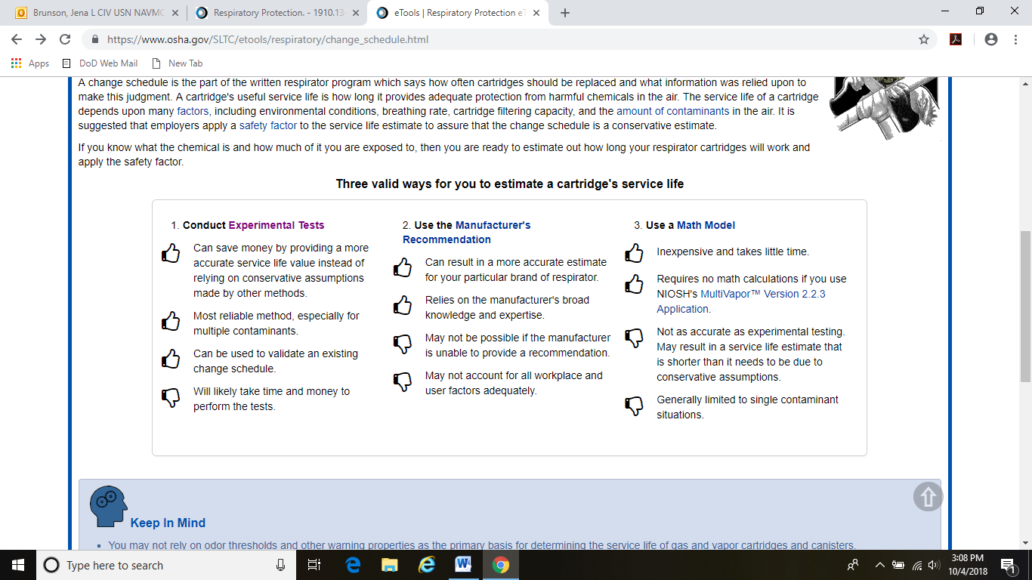**Figure 1 –** [**Three valid ways for you to estimate a cartridge’s service life (OSHA)**](https://www.osha.gov/SLTC/etools/respiratory/change_schedule.html)

* + 1. Experimental tests can be conducted to determine a cartridge’s service life during actual workplace conditions. In the workplace, verify the cartridge change schedule by determining the presence or absence of organic vapor at change time by sampling behind the cartridge. Sampling behind the cartridges during the operation incorporates factors which are problematic to mathematical modeling (i.e., humidity, temperature, atmospheric pressure, breathing rate and varying concentrations of multiple contaminants), into an empirical measurement that determines the presence or absence of chemical breakthrough. In Reference 2, OSHA describes two procedures for determining a cartridge’s service life. One is to use a leak free cartridge holder, adaptors, inert tubing and tee, sampling tube, and a sampling pump as shown in Figure 2, below. Another procedure is to use a quantitative fit-testing (QNFT) sampling adapter between the cartridge and the facepiece as shown in Figure 3, below. For more information, visit the OSHA Respiratory Protection eTool, Reference 2.

**Figure 2 –** [**Experimental Procedure 1 per OSHA**](https://www.osha.gov/SLTC/etools/respiratory/testing_evaluation.html)

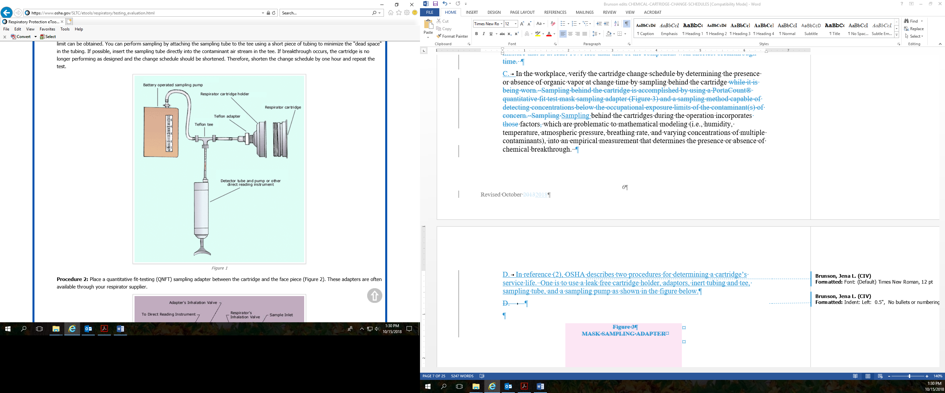

**Figure 3 –** [**Experimental Procedure 2 per OSHA**](https://www.osha.gov/SLTC/etools/respiratory/testing_evaluation.html)

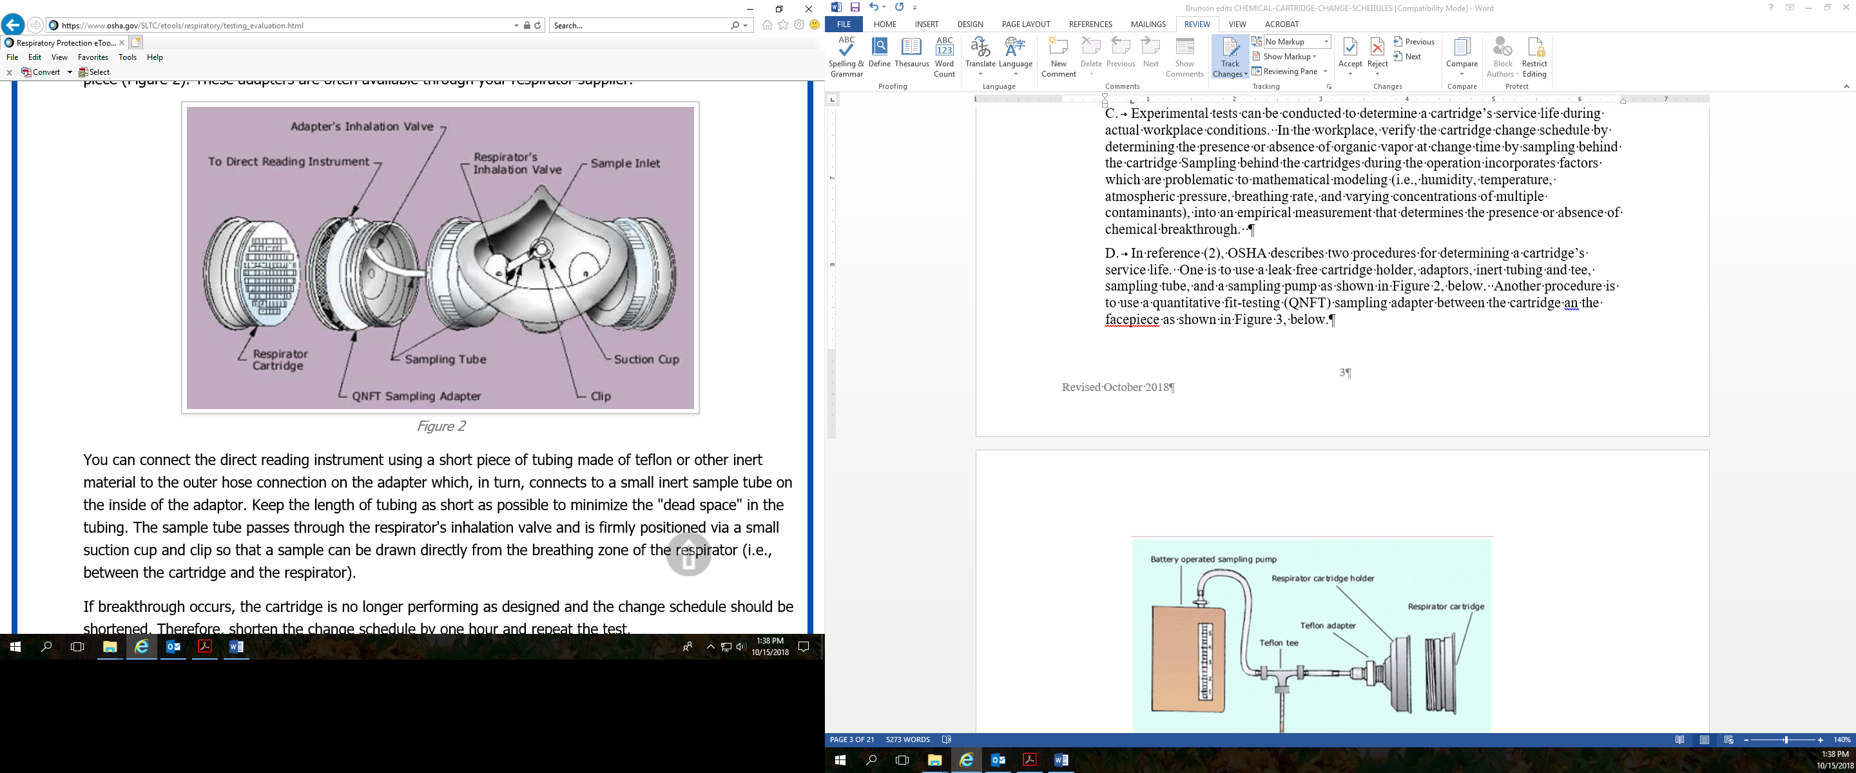

* + 1. Respirator Manufacturers typically offer guidance regarding change out schedules for their cartridges. Information such as the concentration of the contaminant of concern, humidity and work rate may be needed to use the guidance.
    2. Reference 2 provides examples of mathematical models, one of which is the Gerry O. Wood Mathematical Model Equation. This model may be used to predict the service life of respirator cartridges designed to remove a single organic vapor contaminant. OSHA used the equation to develop a table that contains pre-calculated service lives for various single contaminants. The table can be found in the math model section of Reference 2. The use of a math model first requires characterization of the chemical exposure concentrations in the workplace, and then involves estimating breakthrough times for each organic component of the mixture. Breakthrough time can be calculated by performing experimental tests, using specific manufacturer recommendations or using a math model as described in Reference 2. NIOSH provides the MultiVapor™ Version 2.2.5 Application, Reference 8, which is a tool designed to estimate breakthrough times and service lives of air-purifying respirators.

## Chemical Mixtures: Mole Fraction Method

* 1. The mole fraction method is several step process for establishing and implementing respirator cartridge change schedules for mixtures of chemicals and incorporates factors, which are problematic to mathematical modeling (i.e., humidity, temperature, atmospheric pressure, breathing rate and varying concentrations of multiple contaminants).
  2. Step 1 – Characterize the workplace. Determine the frequency and duration of exposure for employees wearing respirators for protection against gas and vapor contaminants. Ideally, the Upper Tolerance Limits (UTL95%, 95%), the concentrations below which we are 95 percent confident that 95 percent of exposures lie, should be determined by following the strategies in Reference 9. For a detailed explanation of the exposure assessment process consult Reference 10. Chapter four of Reference 9 states that six to ten samples from randomly selected members of a "similar exposure group" are required to allow statistically valid inferences to be drawn. In the absence of UTL95%, 95% concentrations, use the worst case exposure data to estimate exposure. The following exposure data will be used to illustrate establishing respirator cartridge change schedules with this method:
     1. Scenario: Air monitoring determined the following workplace UTL95%, 95% concentrations: 65 ppm toluene, 60 ppm n-hexane, 75 ppm isobutyl acetate, and 15 ppm ethyl benzene. Employees use the respirator for seven hours during an eight hour shift. The temperature of the workplace is 75°F with a relative humidity of 40%.
  3. Step 2 – Estimate the breakthrough time for each component of the mixture. Use the respirator manufacturer's chemical cartridge service life calculator or the NIOSH MultiVapor Version 2.2.5 Application, Reference 8, to determine the breakthrough time for each component of the mixture. Cartridge service life calculators require information on temperature, relative humidity and worker breathing rate. The breathing or work rate, in liters of air per minute (L/min), determines the amount of contaminated air drawn through the cartridge sorbent material. One study, Reference 11, determined that the average normal breathing rate was 16.7 L/min and the average deep breathing rate was 27.8 L/min.

**Table 1 – Calculated Breakthrough Time**

|  |  |
| --- | --- |
| **Mixture**  **Component** | **Cartridge Service Life Calculator**  **Estimated Breakthrough Time For**  **Single Component (Hours)** |
| toluene | 38.48 |
| n-hexane | 32.32 |
| isobutyl acetate | 27.07 |
| ethylbenzene | 173.73 |

* 1. Step 3 – Calculate the breakthrough time for the mixture and the cartridge change schedule.
     1. Calculate the mole fraction of each mixture component in the workplace based on its UTL95%, 95% concentration or worst case exposure data.
        1. Mole fraction is calculated by dividing concentrations of each mixture component in ppm by total ppm of the mixture.
        2. Based on the mole fraction of the components in the mixture, calculate the estimated breakthrough time for each mixture component relative to its proportion of the mixture (mole fraction times computer calculated breakthrough time).

**Note:** As shown in Table 2, the breakthrough time of the mixture components relative to their mole fractions of the mixture is considerably reduced from the breakthrough times calculated on the chemical cartridge service life calculator.

**Table 2 – Calculate Breakthrough Time of Components Based on their Proportion of the Mixture**

|  |  |  |  |  |
| --- | --- | --- | --- | --- |
| **Mixture Component** | **UTL95%, 95%  Concentration (ppm)** | **Mole Fraction** | **Cartridge Service Life Calculator Estimated Breakthrough Time for Single Component (Hours)** | **Breakthrough Time of Components Based on Mixture (Hours)** |
| Toluene | 65 | 0.3023 | 38.48 | 11.63 |
| n-hexane | 60 | 0.2791 | 32.32 | 9.02 |
| isobutyl acetate | 75 | 0.3488 | 27.07 | 9.44 |
| Ethyl benzene | 15 | 0.0698 | 173.73 | 12.13 |
| Total ppm | 215 |  |  |  |

* + 1. Base the change schedule on the shortest mixture component breakthrough time. Incorporate a safety factor, by selecting a change schedule that is at least 10% less than the shortest mixture component breakthrough time. In this case, n-hexane has the shortest breakthrough time (9.02 hours) relative to the mixture. Ten percent of 9.02 hours is 0.9 hour (54 minutes). Therefore, the change schedule must be less than 9.02 hours minus 0.9 hours, which is 8.12 hours. Since the respirators are worn for a full shift, it would be convenient to change cartridges after one eight hour shift. Count the morning and afternoon breaks along with lunch time as an hour of continuous respirator use during the shift, due to possible chemical migration inside the cartridge.
    2. For convenience, a spreadsheet to automatically perform these calculations was developed by the Navy and Marine Corps Public Health Center and is provided in Appendix A.
  1. Step 4 – Record Entry. The change schedule along with the supporting data must be incorporated in the written respirator program (See the worksheet in Appendix A).

## Other Areas of Concern

* 1. The focus of this paper has been on determining cartridge change schedules for mixtures of organic vapors. There will be instances where a change schedule must be determined for a single component. In this case, characterize the workplace exposure as described in step 1 of Section 2. Use the appropriate respirator manufacturer's chemical cartridge service life calculator, the NIOSH MultiVapor Version 2.2.5, Reference 8, to determine the breakthrough time for the single component. Set a convenient change schedule at least 10% less than the estimated breakthrough time.
  2. According to Reference 12,"Where an effective change schedule is implemented, air-purifying gas and vapor respirators may be used for hazardous chemicals, including those with few or no warning properties."
     1. Warning properties include odor, taste or irritant effects. If the odor or irritation threshold of a substance occurs at concentrations greater than the occupational exposure limit (OEL) or the substance causes olfactory fatigue, it is considered to have poor warning properties.
     2. This means that air-purifying respirators can be used for protection against substances, such as isocyanates where cartridge change schedules are established and implemented.
  3. In some instances, low toxicity mixture components with low mole fractions and low concentrations have short estimated breakthrough times. Consider a workplace exposure where the ethane trichloride (1,1,2-trichloroethane) concentration is above the 10 ppm permissible exposure limit (PEL) and the concentrations for isopropanol and ethyl acetate are less than 25% of their 400 ppm PELs. Isopropanol and ethyl acetate have short breakthrough times but 1,1,2-trichloroethane has a much longer breakthrough time. Should we use the longer estimated breakthrough time for 1,1,2-trichloroethane instead of the estimated breakthrough time for isopropanol and ethyl acetate? We could sample behind the cartridge specifically for 1,1,2-trichloroethane. In this case, we are not as concerned about the health effects caused by breakthrough of isopropanol and ethyl acetate in concentrations less than 25% of the PELs since we are more appropriately protecting the worker against 1,1,2-trichloroethane exposure.
  4. If sampling behind the cartridges does detect breakthrough (>25% of occupational exposure limits) then reevaluate workplace air sampling results, chemical cartridge service life calculator estimates and mole fraction calculations. If breakthrough concentration is >25%, worker exposure would not be greater than that measured behind the cartridges.
  5. For mixtures in which the components are not listed, sample for the most characteristic component of the mixture. For example, in a mixture of hydrocarbons, which does not identify the components, sample for octane.
  6. Special care should be taken for chemicals with boiling points below 65°C (149°F) if used after one shift because they are not adsorbed well by the activated charcoal and may migrate through the cartridge. This is especially a problem if the end of the shift is on Friday and the cartridges are stored over a weekend instead of just overnight. Do not use chemical cartridges for chemicals that have breakthrough times less than 15 minutes, such as methylene chloride.
  7. Reference 1 states that cartridge change schedules should ideally be based on tests of breakthrough studies that are conducted under worst-case conditions of contaminant concentration, humidity, and temperature and air flow through the filter element. The worst-case climatic conditions for reducing cartridge service life would occur during the summer months. For economical reasons, consideration should also be given to establishing a change schedule for the winter months when climatic conditions should allow longer use of cartridges.

## References

29 CFR 1910.134, OSHA Respiratory Protection Standard

[Occupational Safety and Health Administration. Respiratory Protection eTool for Respirator Change Schedules](https://www.osha.gov/SLTC/etools/respiratory/change_schedule.html).

29 CFR 1910.1025, OSHA Acrylonitrile Standard

29 CFR 1910.1028, OSHA Benzene Standard

29 CFR 1910.1051, OSHA 1,3-Butadiene Standard

29 CFR 1910.1048, OSHA Formaldehyde Standard

29 CFR 1910.1017, OSHA Vinyl Chloride Standard

MultiVapor™ Version 2.2.5 Application. Department of Health and Human Services, National Institute for Occupational Safety and Health [Publication No. 2010-124C](https://www.cdc.gov/niosh/npptl/multivapor/multivapor.html). Revised June 2018.

NMCPHC-TM6290.91-2, Technical Manual, Industrial Hygiene Field Operations Manual.

Jahn, S., Bullock, W, and Ignacia, J. A Strategy for Assessing and Managing Occupational Exposures, Fourth Edition. American Industrial Hygiene Association. ISBN 978-1-935082-46-0. 2015

1. Sergey A. Grinshpun , Hiroki Haruta , Robert M. Eninger , Tiina Reponen , Roy T. McKay & Shu-An Lee (2009) Performance of an N95 Filtering Facepiece Particulate Respirator and a Surgical Mask During Human Breathing: Two Pathways for Particle Penetration, Journal of Occupational and Environmental Hygiene, 6:10, 593-603, DOI: 10.1080/15459620903120086

OSHA Instruction, CPL 2-0.120, Inspection Procedures for the Respiratory Protection Standard of 25 Sep 98, as revised 14 Jul 2004

Appendix A – Cartridge Change Schedule Worksheet

## Introduction

* 1. Workplace exposures and environmental conditions must first be determined and then entered into the service-life software to calculate breakthrough times. Most service life software calculators are based on exposure from a single contaminant. However, most workplace exposures are from mixtures of chemicals.
  2. Change schedules must be calculated for mixtures when using service-life software that calculates breakthrough for only single contaminants. In the main body of this document are directions explaining how to manually calculate change schedules for multiple organic vapor contaminants using the using the mole fraction method. This Appendix contains a spreadsheet to simplify this process. This spreadsheet calculates breakthrough time for each mixture component relative to its proportion of the mixture using mole fractions. In addition, this spreadsheet is part of a form that can be printed as a permanent record describing the objective data and logic used to establish the change schedule.

## Instructions for Cartridge Change Schedule Spreadsheet

* 1. Spreadsheet Directions. The *Cartridge Change Schedule Worksheet* contains a spreadsheet entitled *Calculate Breakthrough Time of Components Based on Their Proportion in The Mixture,* which performs the mole fraction method calculations automatically.
  2. Fill in the *Cartridge Change Schedule Worksheet* with air sampling results and environmental data concerning workplace temperature, humidity and worker breathing rate.
     1. First, make an electronic copy of the *Cartridge Change Schedule Worksheet* and use a new copy to calculate breakthrough time for each mixture.
     2. Fill in the columns for “*UTL95%, 95% Concentration*” and “*Cartridge Service Life Calculator Estimated Breakthrough Time for Single Component*.”
     3. Then select the “*UTL95%, 95% Concentration*” column and **press F9** to calculate the total parts per million.
     4. Next, block the whole table, and **press F9** to complete the mole fraction calculations and breakthrough time calculations.

**CARTRIDGE CHANGE SCHEDULE WORKSHEET**

Operation: Location:

Respirator Model: Cartridge:

|  |  |  |  |
| --- | --- | --- | --- |
| Chemical | Exposure Limit | Concentration | Boiling Point* |
|  |  |  |  |
|  |  |  |  |
|  |  |  |  |
|  |  |  |  |
|  |  |  |  |
|  |  |  |  |

*Chemicals with boiling points less than 65o C (149o F) may be desorbed from sorbent during periods of non-use.

**OPERATION PARAMETERS:**

Frequency per week: Duration of respirator wear:

Estimated work rate: [ ] Light [ ] Moderate [ ] Heavy

**ENVIRONMENTAL DATA:**

Highest temperature: Highest humidity:

|  |  |  |  |  |
| --- | --- | --- | --- | --- |
| **Calculate Breakthrough Time of Components**  **Based on Their Proportion in The Mixture** | | | | |
| Mixture  Component | UTL95%, 95%  Concentration  (ppm) | Mole  Fraction1 | Cartridge Service Life Calculator  Estimated  Breakthrough Time  for Single Component  (Hours) | Breakthrough Time of Components Based on Mixture  (Hours) |
|  |  | 0.0 |  | 0 |
|  |  | 0.0 |  | 0 |
|  |  | 0.0 |  | 0 |
|  |  | 0.0 |  | 0 |
|  |  | 0.0 |  | 0 |
|  |  | 0.0 |  | 0 |
| Total ppm | 0 |  |  |  |

1Mole Fraction = ppm contaminant / total ppm of the mixture components

Change schedule including safety factor of ten percent:

[ ] Every hours [ ] After each shift [ ] Weekly [ ] Other (specify):

Appendix B – OSHA Rules of Thumb for Computing Breakthrough Times for Mixtures

## OSHA CPL 2-0.120

* 1. OSHA CPL 2-0.120, Inspection procedures for the Respiratory Protection Standard, provide the following two rules of thumb for establishing cartridge service-life for exposure to chemical mixtures:
     1. If mixture component breakthrough times are similar – within one order of magnitude (10 times), add mixture components concentrations and recalculate using respirator manufacturer service-life software assuming the entire mixture behaves like the contaminant with the shortest breakthrough time.
     2. If mixture component breakthrough times vary by two orders of magnitude (100 times) or more, use the shortest breakthrough time.
        + 1. Example of mixture component breakthrough times within one order of magnitude. The following breakthrough times for mixture components were calculated using respirator manufacturer service-life software.

Component A = 100 ppm; estimated service life = 10 hr

Component B = 200 ppm; estimated service life = 100 hr

Component C = 300 ppm; estimated service life = 50 hr

* + - * 1. In this mixture, the breakthrough times of the mixture components are within one order of magnitude of each other. Therefore, add the component concentrations and recalculate breakthrough for the component with the shortest breakthrough time using this sum.

100 + 200 + 300 = 600 ppm

* + - * 1. Using manufacturer service-life software, recalculate Component A at 600 ppm. In this example, the recalculation estimates the service-life to be six hours. Therefore, use six hours as the mixture breakthrough time.
  1. Example of mixture component breakthrough times exceeding two orders of magnitude.
     1. The following breakthrough times for mixture components were calculated using respirator manufacturer service-life software.
     2. In this mixture, the differences between breakthrough times of mixture components are greater than two orders of magnitude. Therefore, use the breakthrough time of the component with the shortest breakthrough time as the change schedule for the mixture. In this case Component A has the shortest breakthrough time, so use 10 hours as the breakthrough time for the mixture.

Component A = 100 ppm; estimated service life = 10 hr [**shortest]**

Component B = 2 ppm; estimated service life = 10,000 hr

Component C = 30 ppm; estimated service life = 500 hr

1.